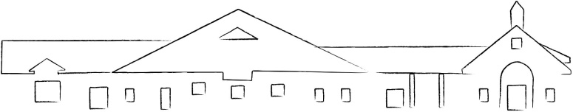
Grayson County Public Library
163 Carroll Gibson Blvd. Leitchfield, KY 42754

phone: (270)-259-5455
fax: (270)-259-4552
www.graysoncpl.org

Advertisement for Executive Director

The Grayson County Public Library is in search of a qualified, service-oriented Executive Library Director to manage and oversee library operations. The library serves an area of approximately 26,000 citizens and currently employees 9 full and part-time staff. The projected start date for the position is July 1st, 2021.

The Director is responsible for planning and supervising the overall operation of the library, including management of staff, collections, public relations, programming, and fiscal management. The Director reports to and acts in an advisory capacity to the Board of Trustees.

A Master’s Degree in Library Science is required along with Professional Certification from KDLA or an ability to get Professional Certification from KDLA. A minimum of five (5) years of experience working in a public library along with a thorough understanding of library principles and procedures is preferred.

The salary range is $56,000 to $58,000 and is dependent on education level and experience. The library offers a generous benefit package that includes retirement, health insurance, vacation and sick leave.

The Grayson County Public Library does not discriminate in employment on the basis of race, color, religion, sex (including pregnancy and gender identity), national origin, political affiliation, sexual orientation, marital status, disability, genetic information, age, membership in an employee organization, retaliation, parental status, military service, or other non-merit factor.

For more information and a full job description or to apply visit: http://www.graysoncpl.org/

Resumes and a completed application can be emailed to: gcplboard@graysoncpl.org

or mailed to:

Grayson County Public Library
Attn: Kindra Jones
163 Carroll Gibson Blvd.
Leitchfield, KY 42754

